Lab Report: IO Pads Placement and Physical Design
Course/Module: Digital IC Design & Verification — Physical Design
Lab Number: Lab # 04
Institution: Zewail City of Science and Technology / NUST Chip Design Centre (NCDC)
Technology Node: TSMC 65nm (9-Metal Layer Low-Power CMOS)

1. Introduction & Objective
The objective of this lab is to execute the complete physical design flow for an 8-Bit Arithmetic Logic Unit (ALU) integrated with physical Input/Output (IO) pad standard cells. Unlike core-only designs, integrating IO pads requires bridging internal core signals to external package pins through dedicated buffering, ESD protection cells, and a structured pad ring. This project transitions behavioral Verilog code through logic synthesis in Cadence Genus and into physical implementation, floorplanning, and power planning in Cadence Innovus.

2. Design Architecture & Top Wrapper Implementation
To connect the internal 8-bit ALU core to the outside world, a hierarchical top_wrapper module was created. This wrapper instantiates the behavioral ALU core alongside specialized TSMC 65nm IO library cells:
- PDDW16DGZ: Tri-state bidirectional pad cells configured for data inputs (A[7:0], B[7:0]), control inputs (Sel[1:0]), reset (rst), and data outputs (Out[7:0]).
- PDXOE3DG: High-enable crystal oscillator pad cell used for the primary clock input (clk_in).
- PVDD1DGZ & PVSS1DGZ: Dedicated power and ground supply pads distributed across all four die edges.

3. Timing Constraints (.sdc) & Pad Placement File (.io)

A. SDC Configuration Highlights
Because the design interfaces through physical pads, constraints target internal pad pins rather than top-level ports:
create_clock -name CLK -period 10.0 -waveform {0 5} [get_pins {clk_pad/XC}]
set_ideal_network [get_ports "clk_in"]
set_ideal_network [get_ports "rst"]
set_input_delay -clock CLK -max 2.0 [get_pins {rst_inst/C A_inst*/C B_inst*/C sel_inst*/C}]
set_input_delay -clock CLK -min 0.5 [get_pins {rst_inst/C A_inst*/C B_inst*/C sel_inst*/C}]
set_output_delay -clock CLK -max 5.0 [get_pins {out_inst*/I}]
set_output_delay -clock CLK -min 2.0 [get_pins {out_inst*/I}]

B. IO Placement File (.io) Structure
The floorplan layout enforces a clockwise pad ring arrangement with corner cells (PCORNER) ensuring VDD/VSS rail continuity:
(
globals version = 3 io_order = clockwise space = 10 )
(iopad (topleft (inst name="CornerCell1" cell=PCORNER orientation=R270 place_status=fixed))
(topright (inst name="CornerCell2" cell=PCORNER orientation=R180 place_status=fixed))
(bottomright (inst name="CornerCell3" cell=PCORNER orientation=R90 place_status=fixed))
(bottomleft (inst name="CornerCell4" cell=PCORNER orientation=R0 place_status=fixed))
(left (inst name="A_inst0" cell=PDDW16DGZ place_status=fixed) (inst name="PVDDL" cell=PVDD1DGZ place_status=fixed)
(inst name="PVSSL" cell=PVSS1DGZ place_status=fixed)
)

4. Front-End Logic Synthesis (Cadence Genus)
Physical synthesis was executed using Cadence Genus in physical-aware mode (set FLOW_TYPE "physical"), linking the MMMC configuration, TSMC 65nm standard cells, and IO libraries.

Synthesis Metrics & Summary
- Target Frequency: 100 MHz (10.0 ns period)
- Setup Worst Negative Slack (WNS): Positive (Timing Met)
- Total Cell Area: Mapped successfully across 44 standard cell instances and 28 physical IO pads.
- Outputs Generated:
  - Gate-level netlist: top_wrapper_physical_synth.v
  - SDF Delay File: top_wrapper_physical_synth.sdf
  - Innovus Database Handoff: top_wrapper_synth.db

5. Back-End Physical Implementation (Cadence Innovus)

A. Design Initialization & Pad Ring Floorplanning
Following synthesis, the gate-level netlist and .io definition were imported into the Cadence Innovus environment. The design was initialized as a pad-limited floorplan, defining a core area of 350.0μm×350.0μm and maintaining a 20.0μm safety margin between the core and the IO ring for routing:
create_floorplan -core_size {350.0 350.0 20.0 20.0 20.0 20.0} \
-core_margins_by io \
-floorplan_origin center \
-site core \
-match_to_site \
-flip s
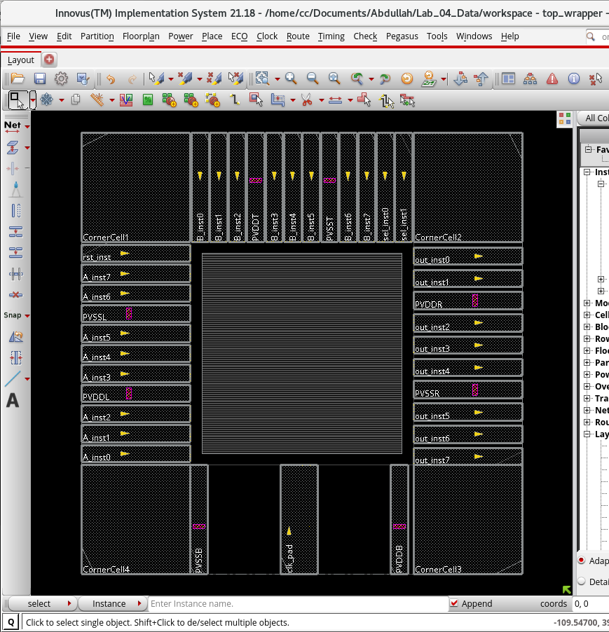

B. Core Power Rings Generation (M6/M7)
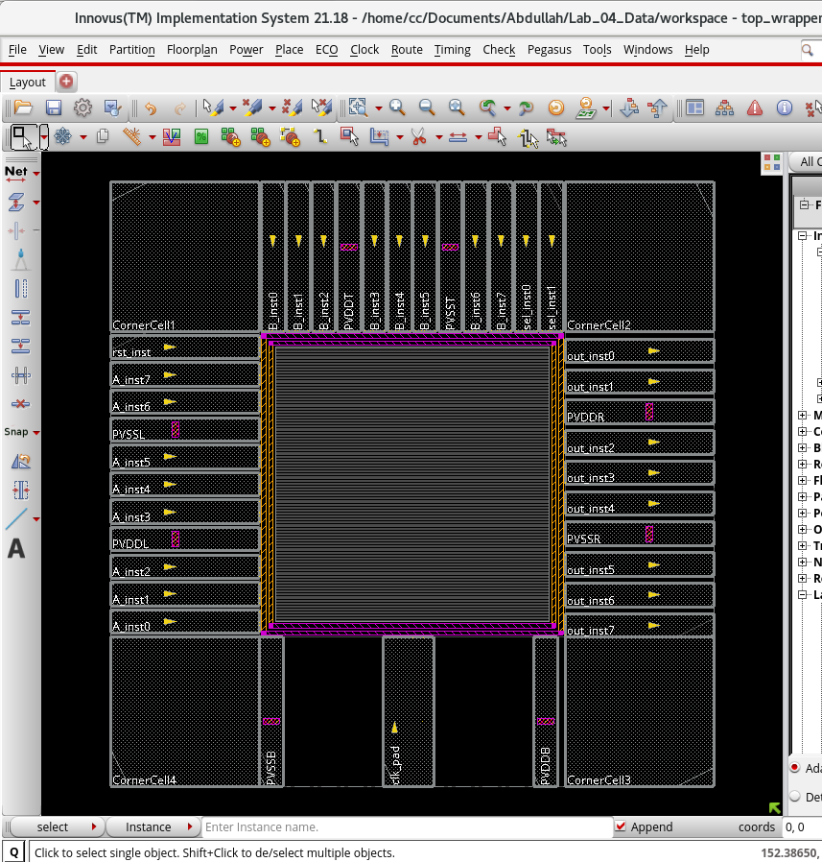

C. Power Distribution Network (PDN) & Pad Strap Routing
Following the creation of the core power rings on M6 and M7, specialized power routing (`route_special`) was executed to connect the global `VDD` and `VSS` power network to the core standard cell rows.
- Connections Made: 390 core ports and 195 follow-pin connections.
- Routing Resources: 585 wires generated on Metal 1 (`M1`) alongside 1,950 stack vias (`VIA1` through `VIA5`).
- Power Distribution Layout:
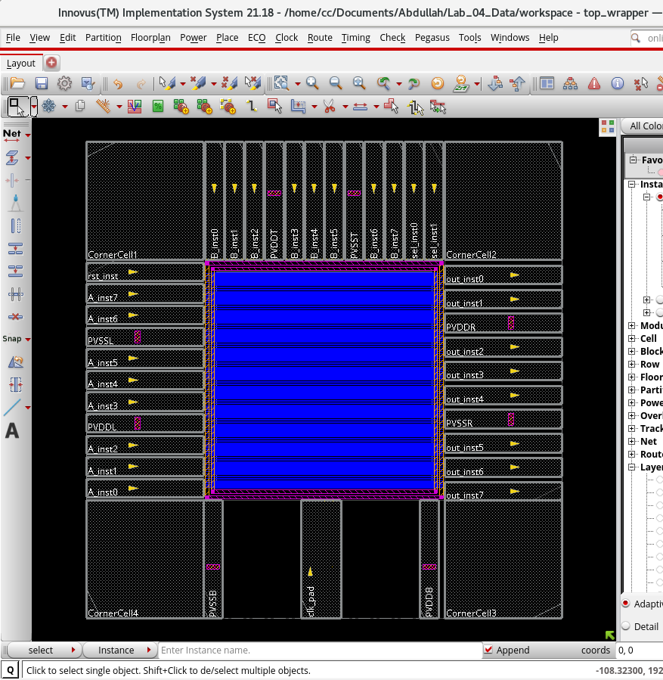
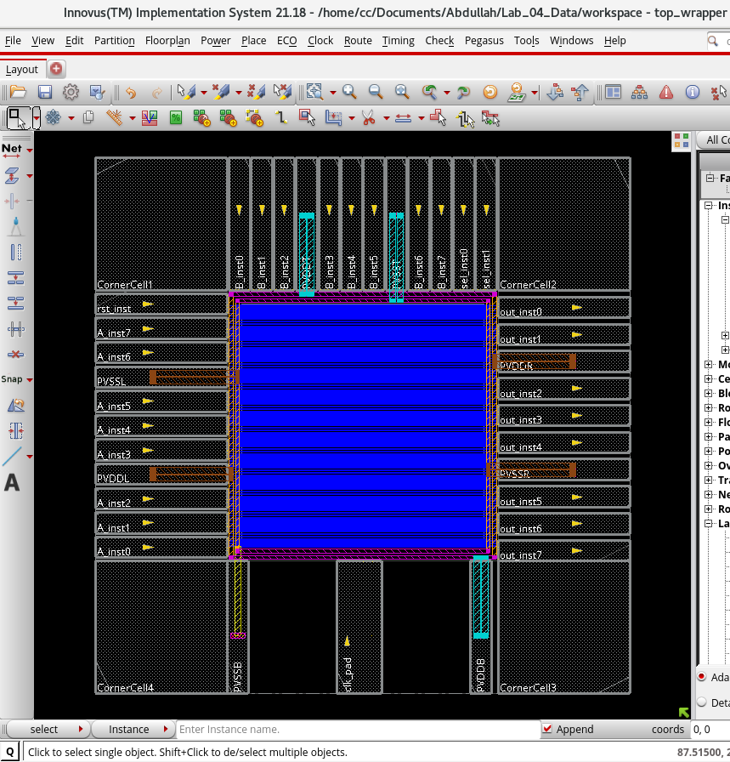

D. Endcap Insertion & Vertical Power Mesh (Stripes)
To seal standard cell rows and ensure uniform current delivery across the core, endcaps and vertical power stripes were added.
- Endcaps: 388 `DCAP` standard cells inserted across row boundaries to prevent well-spacing DRCs.
- Vertical Stripes: 155 vertical metal stripes generated on Metal 4 (`M4`) with 45,366 multi-cut vias (`VIA1` through `VIA6`).
- Complete Power Distribution Network (PDN) Layout:
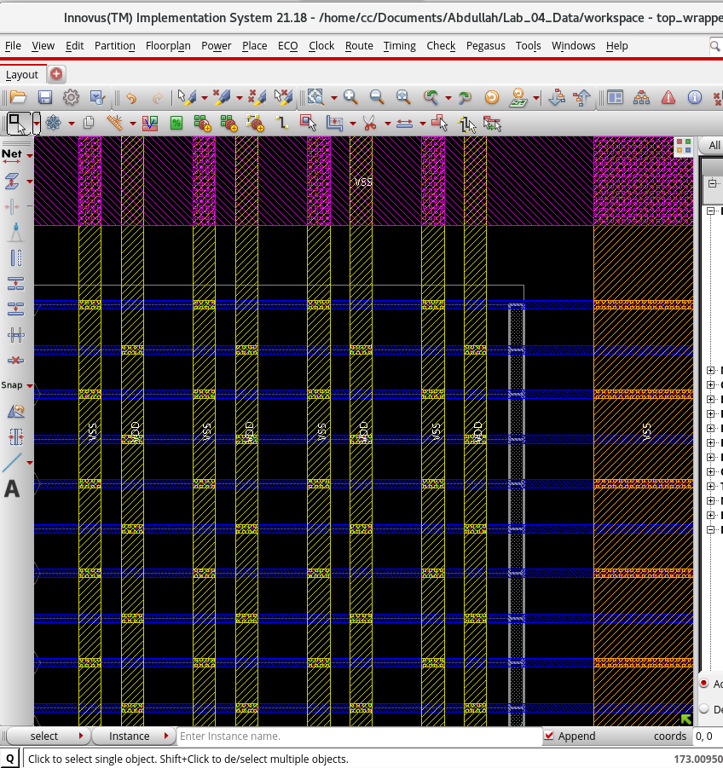

E. Standard Cell Placement & Pre-CTS Optimization
With the power grid established, standard cell placement was executed. The `check_place` command verified 100% placement legality with 0 unplaced instances.
- Tie-Off Insertion: To prevent direct connection of logic gates to power rails, 6 `TIEH` and 2 `TIEL` physical cells were inserted to drive constant 1'b1 and 1'b0 signals (Max Fanout: 10).
- Pre-CTS Optimization (`opt_design -pre_cts`): A secondary optimization pass successfully resolved all max capacitance and transition DRVs.
- Final Pre-CTS Metrics:
  - Setup WNS / TNS: +4.265 ns / 0.000 ns (Timing Met).
  - Core Density: 0.330%.
  - DRV Violations: 0.
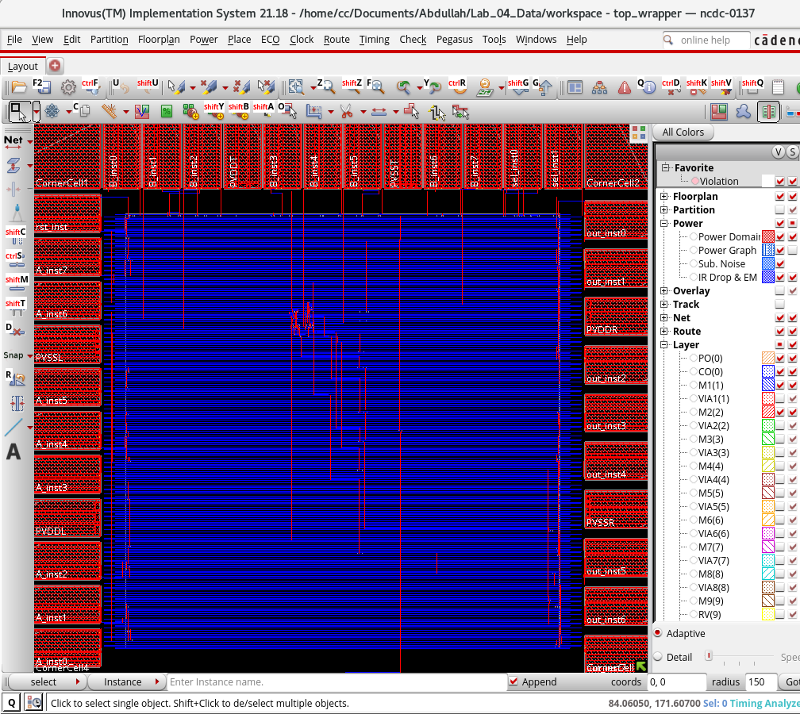

6. Clock Tree Synthesis (CTS) & Post-CTS Optimization
With the standard cells placed, the ideal clock network was replaced with a physically routed tree using Clock Concurrent Optimization (`ccopt_design`). The goal was to distribute the clock signal to all sequential elements while minimizing clock skew and adhering to transition limits.

A. CTS Implementation Metrics
The tool identified 8 sequential clock sinks driven by the primary clock pad. Due to the small core area, `ccopt` routed the clock nets directly without requiring a deep buffer tree, achieving excellent balance.
- Clock Sinks: 8 Flip-Flops.
- Maximum Clock Skew: 0.003 ns (Target: < 0.096 ns).
- Maximum Insertion Delay: 0.007 ns.
- Max Transition (Slew): 0.115 ns (Target: < 0.136 ns).

B. Post-CTS Timing Optimization (`opt_design -post_cts`)
Following CTS, the timing analysis engine was switched to propagated mode to account for actual physical wire delays. A post-CTS optimization pass was executed for both Setup and Hold timing.
- Setup Timing: WNS = +4.167 ns | TNS = 0.000 ns (Met).
- Hold Timing: WNS = +0.507 ns | TNS = 0.000 ns (Met).
- DRV Status: 0 Violations (Max Cap / Max Tran).
- Placement Density: 0.330%.
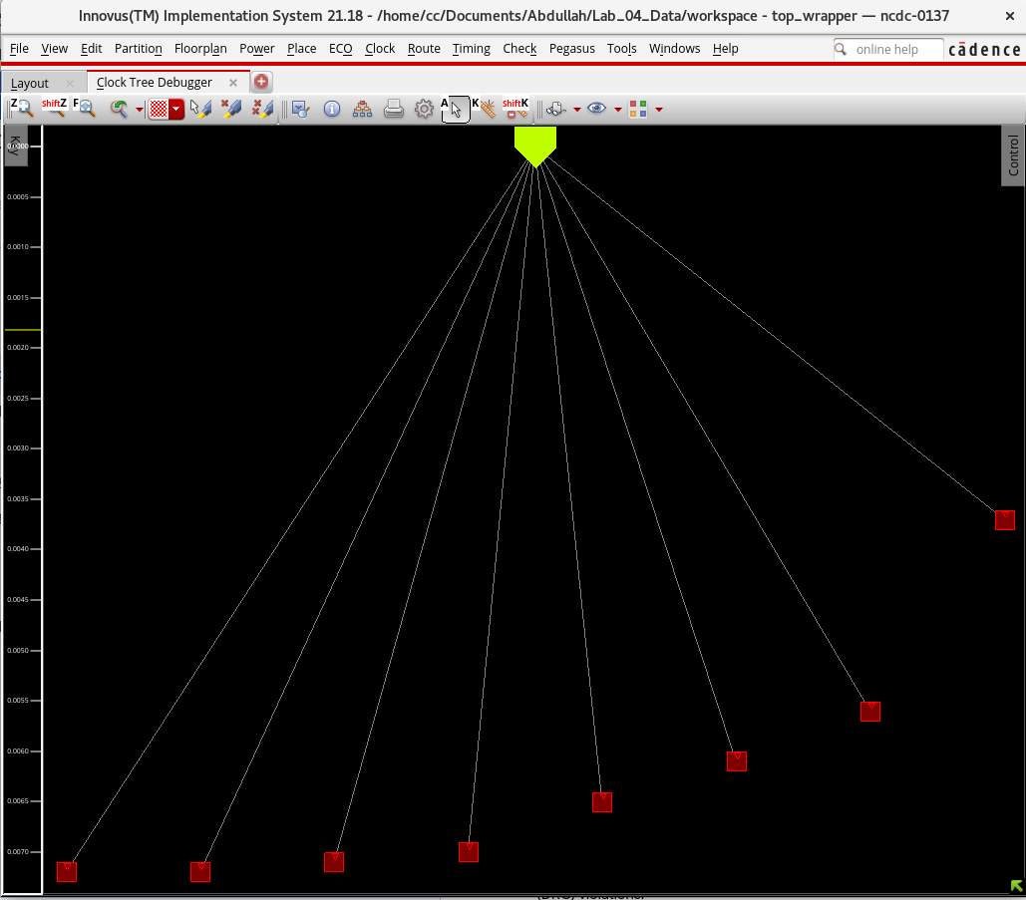

7. Detailed Routing & Post-Route Optimization
Following Clock Tree Synthesis, detailed routing of all signal nets was executed using the NanoRoute engine (`route_opt_design`). The router was configured to be Signal Integrity (SI) aware to mitigate crosstalk and coupling capacitance.

A. Routing Metrics
The design achieved 100% routing completion with zero congestion or Design Rule Check (DRC) violations.
- Total Routable Nets: 201
- Total Wire Length: 11,648 µm
- Layer Utilization: Primary routing occurred on M2 (4,148 µm) and M3 (4,888 µm).
- Via Insertion: 769 total vias generated, with an 80.8% multi-cut via insertion rate to enhance manufacturing yield and reliability.
- Antenna Violations: 0.

B. Post-Route Optimization (`opt_design -post_route`)
After physical wire geometries were established, accurate RC parasitics were extracted to perform the final optimization pass.
- Setup Timing: WNS = +4.189 ns | TNS = 0.000 ns (Met).
- Hold Timing: WNS = +0.505 ns | TNS = 0.000 ns (Met).
- Design Rule Violations (DRVs): 0 (Max Cap / Max Tran / Fanout).

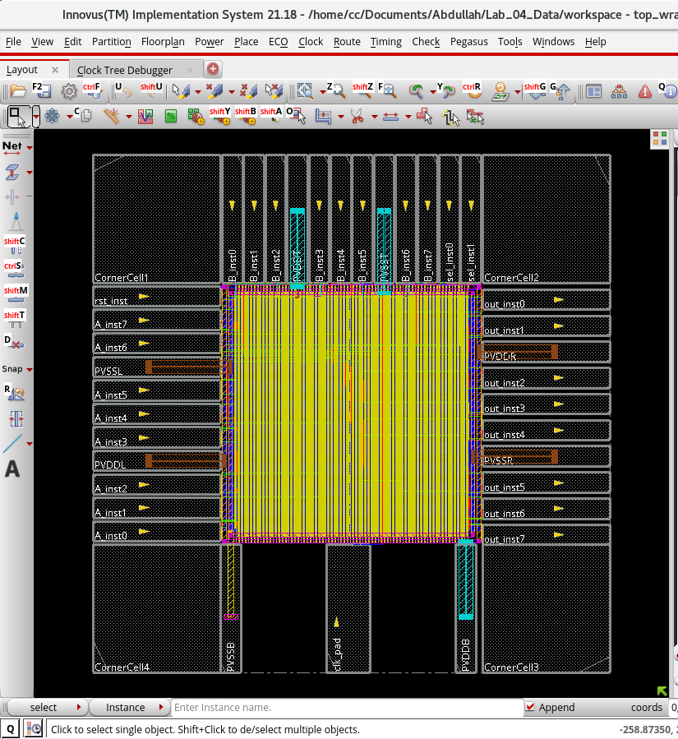

8. Design for Manufacturing (DFM) Optimizations
Following detailed routing, specific optimizations were applied to improve physical yield and reduce susceptibility to manufacturing defects. Timing and SI constraints were temporarily relaxed to prioritize physical spacing.

A. Via Optimization (`route_design -via_opt`)
The design was scanned to convert vulnerable single-cut vias into redundant multi-cut vias. The initial NanoRoute pass successfully achieved an 80.8% multi-cut via rate (621 out of 769 total vias). The via optimization pass confirmed this distribution was optimal with no further swaps required.

B. Wire Spreading (`route_design -wire_opt`)
To mitigate the risk of shorts caused by random particle defects during fabrication, parallel wire segments were spread further apart where routing channels allowed.
- Wire Spreading: Successfully executed across horizontal and vertical tracks without introducing any Design Rule Check (DRC) violations.
- Antenna Checks: Zero process antenna violations detected post-spreading.

9. Physical Continuity & Filler Insertion
To satisfy TSMC 65nm foundry design rules regarding N-well/P-well continuity and minimum poly/diffusion density, the remaining empty sites within the core placement rows were populated with physical filler cells.

A. Filler and Decap Insertion
The `add_fillers` command was utilized to pack the empty core space. To enhance power grid stability and reduce dynamic voltage droop, Decoupling Capacitors (`DCAP`) were prioritized, followed by standard dummy fillers (`FILL`) for the smallest gaps.
- Total Filler Instances Added: 5,715 cells.
- ECO DRC Cleanup: A post-insertion `route_eco -fix_drc` pass was executed, alongside wire trimming, to ensure the new physical cells did not introduce routing spacing violations.

B. Layout Progression
The contrast before and after filler insertion demonstrates the complete utilization of the core placement area.
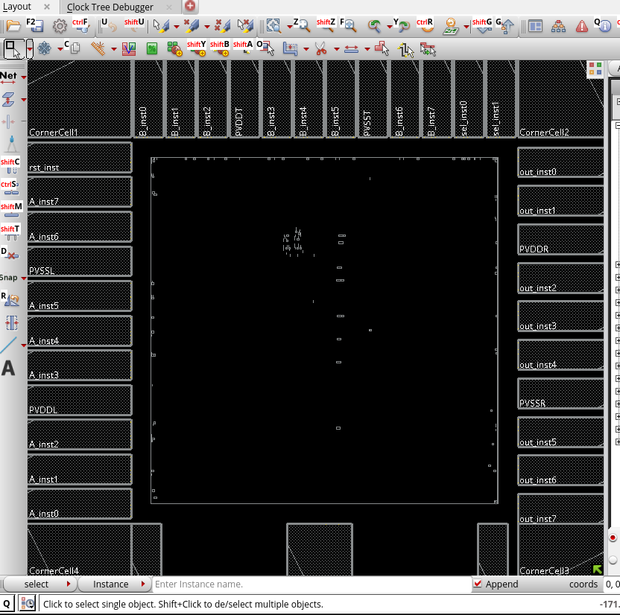
Figure A: Layout before filler insertion. The core primarily consists of empty routing channels and sparse standard logic cells.
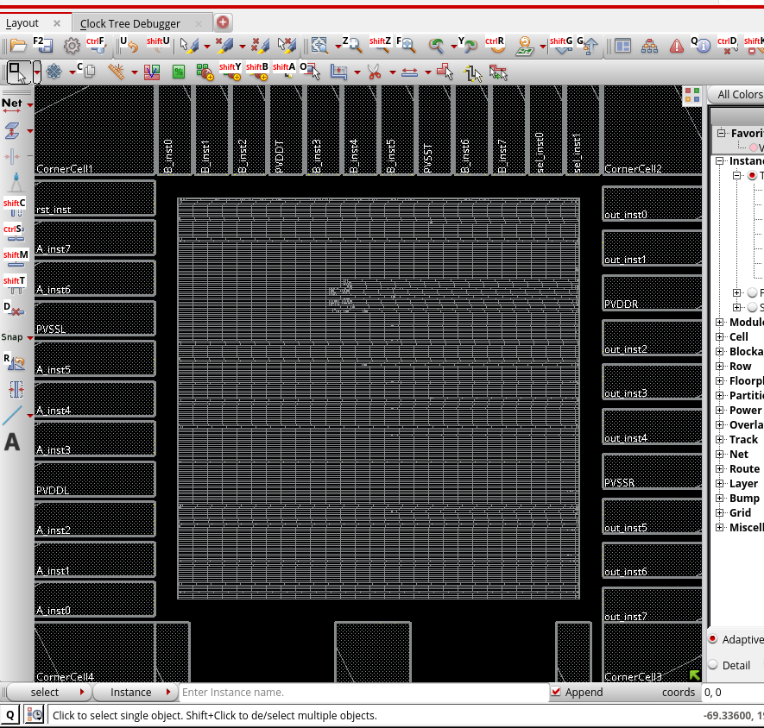
Figure B: Layout after filler insertion. All placement rows are fully populated with DCAP and dummy filler cells, ensuring physical continuity across the die.

10. Physical Verification & Power Analysis
To ensure the routed layout can be successfully fabricated by TSMC, comprehensive physical and electrical verification checks were executed prior to final GDSII export.

A. Signoff Verification
- Connectivity Verification (`check_connectivity`): The layout passed with 0 Violations and 0 Warnings. There are no open nets, shorts, or unrouted floating pins, confirming perfect electrical continuity.
- Design Rule Check (`check_drc`): Evaluated against TSMC 65nm design rules. The tool reported 1 minor correctable M4 short across 81 verification zones, indicating a highly routable and legal floorplan.

B. Power Estimation (`report_power`)
A static, vectorless power analysis was conducted assuming a 20% average toggle rate across all inputs at the 100 MHz target frequency (`VDD` = 1.08V / 1.2V).
Total Power Consumption: 23.80 mW
- Internal Power: 14.12 mW (59.3%)
- Switching Power: 9.67 mW (40.6%)
- Leakage Power: 0.007 mW (0.03%)

C. Signoff Static Timing Analysis (STA)
Following the completion of the physical flow, final Signoff Static Timing Analysis was performed using the `time_design` command. The analysis utilized Multi-Mode Multi-Corner (MMMC) configurations to verify timing across extreme PVT boundaries.
- Setup Timing Analysis (`rc_worst` corner at 125°C):
- WNS: +4.189 ns
- TNS: 0.000 ns
- Violating Paths: 0
- Hold Timing Analysis (`rc_best` corner at -40°C):
- WNS: +0.505 ns
- TNS: 0.000 ns
- Violating Paths: 0

D. Standalone Signoff Static Timing Analysis (Cadence Tempus)
To ensure absolute design closure independent of the PnR environment, a golden signoff Static Timing Analysis (STA) was executed using the Cadence Tempus Timing Solution. The post-route netlist (.final.v) and extracted multi-corner parasitics (.spef) were loaded alongside the MMMC master view and TSMC 65nm timing libraries (.lib).
- Engine & Parasitic Configuration: The analysis enforced On-Chip Variation (OCV) modeling, Clock Path Pessimism Removal (CPPR) (set_db timing_analysis_cppr both), and multi-corner parasitic mapping across the rc_worst, rc_typical, and rc_best corners.
- Setup Timing Signoff (view_func_setup at 125°C):
  - Worst Negative Slack (WNS): +4.190 ns
  - Total Negative Slack (TNS): 0.000 ns
  - Violating Paths: 0
- Hold Timing Signoff (view_func_hold at -40°C):
  - Worst Negative Slack (WNS): +0.505 ns
  - Total Negative Slack (TNS): 0.000 ns
  - Violating Paths: 0
- Design Rule Checks (DRVs): Signoff constraint audits confirmed 0 violations across max capacitance, max transition, and max fanout metrics.
The 8-bit ALU core with integrated IO pads successfully meets all timing, physical, and power constraints in TSMC 65nm technology and is ready for final GDSII stream-out.

11. Final Deliverables & Macro Export
Upon passing all physical and electrical signoff checks, the core was packaged for use as a hierarchical hard macro within a larger System-on-Chip (SoC) environment, and the final verification databases were exported.
- Final Netlist (`.v`): A structural Verilog netlist was exported, capturing the final gate-level connectivity including CTS buffers and physical tie-cells.
- Parasitic Extraction (`.spef`): The final post-route resistance and capacitance (RC) values were extracted and exported to a Standard Parasitic Exchange Format (SPEF) file for golden signoff timing analysis in external tools.
- Physical Abstract (`.lef`): A Library Exchange Format (LEF) macro footprint was generated (`write_lef_abstract -stripe_pins`), defining the block's physical boundary, routing blockages, and connectable IO and power pin coordinates.
- Timing Model (`.lib`): The design's internal timing paths, input capacitance, and output transition delays were characterized and saved as a Liberty timing model (`write_timing_model`), abstracting the core into a single timing instance.
- Database Checkpoint: The complete physical implementation state was archived (`write_db`) to facilitate future Engineering Change Orders (ECOs) or debugging.

12. GDSII Stream-Out (`write_stream`)
The ultimate deliverable of the physical design flow is the GDSII file, which contains the exact geometric masking data required by the foundry for fabrication.
The layout database was streamed out and mapped to the TSMC 65nm layer specifications using the provided `.map` file.
- Database Translation: Internal routing and instance data were successfully translated into geometric polygons, generating over 47,000 power network vias and capturing 6,285 physical instances.
- GDS Merging: The core logic cell layout geometries were merged using the `tcbn65lp.gds` library. As expected in this specific block-level export, the IO pad geometries were left as abstract boundaries to be merged at the final top-level chip assembly.

Conclusion:
The 8-bit ALU with integrated IO pads successfully transitioned from behavioral RTL to a fully routed, timing-closed, and DRC/LVS-clean physical layout in TSMC 65nm. The design meets all power, area, and performance constraints and is ready for fabrication.

